**What is Gensingen brace by Dr. Weiss (GBW)**

Parents looking for scoliosis brace should focus on key factors like effectiveness, comfort, the potential for improving the curve, and better postural symmetry. The Chêneau-Gensingen Brace stands out for offering these advantages and more compared to other scoliosis braces. Recent evidence shows that the Gensingen Brace has a remarkable >90% success rate, highlighting its effectiveness in managing scoliosis and improving outcomes for patients.

Key points for Gensingen brace (GBW brace)

* New and improved modern brace
* For mild, moderate, and severe scoliosis
* **Asymmetric design** for true 3D correction
* >90% success rate in preventing scoliosis surgery
* Proven in-brace correction, aiming for **overcorrection** when possible (dependent on the patient)
* Improves posture, giving a more balanced appearance
* Pressure zones and openings at spinal concavities help induce correction and reduce spinal rotation
* Developed using the Augmented-Lehnert Schroth Classifications – the only Chêneau type brace approved by the Schroth method family
* Can be used alone or alongside our Schroth Best Practice scoliosis exercise program for optimal results.
* Easy to wear which improves compliance
* 3D scanning technology provides fast, accurate and painless measurement

Factors affecting improvement

The potential outcomes of scoliosis treatment with a brace depend on several important factors, including spinal flexibility, curve severity at the start of bracing, Risser stage (a measure of skeletal maturity), and the patient’s commitment to wearing the brace as prescribed. Each of these factors plays a key role in determining how effective the treatment will be in preventing curve progression or improving the curve.

Spinal flexibility is critical because a more flexible spine can be more easily corrected by a brace. If the spine is stiff, the treatment may be less effective, which is why early detection is so important. Identifying scoliosis in its early stages gives patients the best chance to treat the curve before it becomes rigid and harder to manage. The severity of the curve when bracing starts also matters; the earlier the intervention, the better the potential for reducing or halting curve progression, especially in cases of moderate or severe curves.

The Risser stage, which indicates how much growth a child has left, is another important factor. Younger patients who are still growing have a higher potential for improvement through bracing, as their bones are more responsive to corrective forces. This underscores why early diagnosis and intervention are crucial for achieving the best outcomes.

Compliance with wearing the brace is perhaps the most significant factor. A brace will only work if the patient wears it consistently as recommended. At ScolioRehab Ipoh, we are deeply committed to making the brace as comfortable as possible to encourage this compliance. We understand that wearing a brace can be challenging, so we take extra care to ensure that the brace fits well and does not cause discomfort. By working with each patient to adjust and refine the fit, we maximize comfort and improve the chances of wearing the brace for the necessary amount of time each day.

Additionally, we provide ongoing support throughout the bracing process to ensure that patients and their families feel confident and well-informed. We don’t just fit the brace and send patients on their way – we guide them through every step, answer questions, and offer adjustments as needed. Our goal is to make the process as smooth and effective as possible, ultimately improving the outcome and giving patients the best chance for a healthier spine.

**Why is compatibility for Schroth exercise and the brace is important?**

Compatibility between the Schroth exercises and the brace is important because it ensures both work together to achieve the best results for scoliosis management. When a brace is designed to complement the Schroth method, it supports the spine in a corrected position, while the exercises focus on strengthening and stabilizing the muscles around the spine.

Using a brace that aligns with the principles of the Schroth method allows patients to maintain corrected posture during daily activities. The brace provides structural support, while the exercises retrain muscles and improve posture in the long term. This combination helps prevent curve progression, promotes spinal alignment, and supports healthier movement patterns. At ScolioRehab Ipoh, we ensure this compatibility to maximize the effectiveness of both treatments for our patients.

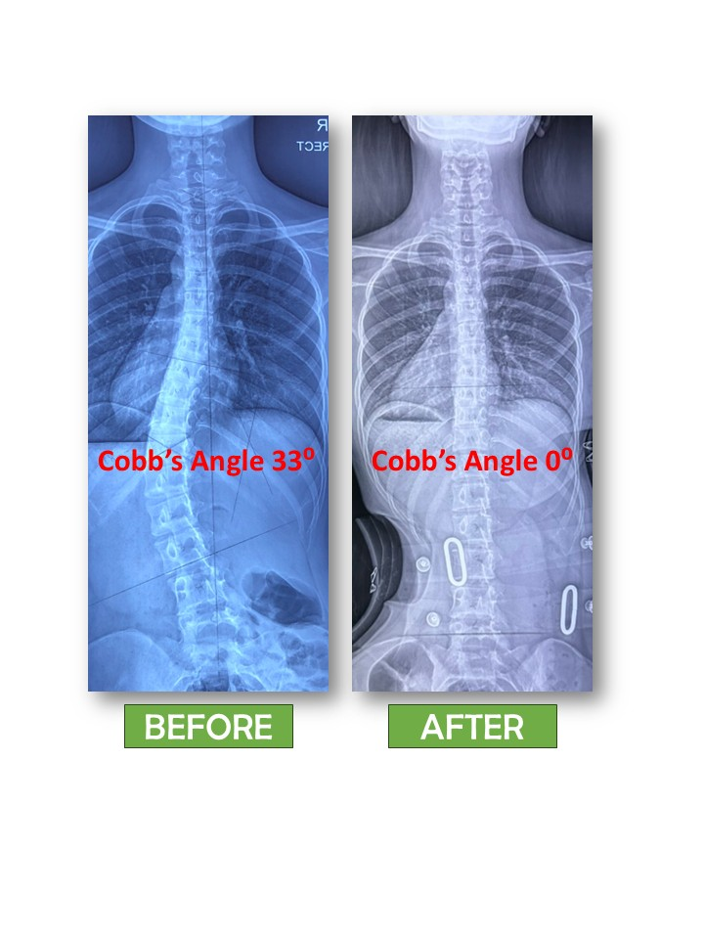

Sample case of Adolescent Idiopathic Scoliosis managed with GBW, Cobb’s angle reduced from 33 Degrees to 0 Degrees.

**Brace Production Process**

1. **Scanning and Assessment**: The process begins with a detailed 3D scan of the patient's spine, combined with full spine X-rays and a postural assessment. This helps to accurately capture the curvature and individual characteristics of the spine. Advanced CAD/CAM technology allows for standardization and eliminates manufacturing variances and human error.
2. **Data Verification**: The scanned data is then sent to the **Gensingen Brace Headquarters (GBW)** for a thorough verification check. This ensures that the measurements and specifications meet the required standards for quality control and accuracy.
3. **Fabrication of the Hard Brace**: Once the data is verified, the **hard brace** is fabricated based on the unique needs of the patient, following precise measurements and ensuring the best fit for effective scoliosis treatment.
4. **Brace Fitting and Trimming**: The fabricated brace is then carefully fitted to the patient. Any necessary trimming is done to ensure comfort while maintaining its corrective function. This is a crucial step for ensuring the patient can wear the brace comfortably throughout the day.
5. **Regular Check-ups and Adjustments**: As the scoliosis curve improves, regular follow-up appointments are scheduled to assess progress. During these visits, the brace may be trimmed or adjusted to ensure that it continues to fit well and effectively correct the spine as the patient’s condition improves.
6. **Servicing the Brace**: The brace is serviced periodically to ensure that it remains in optimal condition, adjusting for any changes in the patient’s posture, curve, or growth. This ongoing maintenance helps to ensure the brace continues to provide the necessary support and correction throughout the treatment process.